|  |  |
| --- | --- |
| **YEAR 8** | **Heat (Thermal) Energy** |

|  |  |
| --- | --- |
| **Learning Intentions** | **Success Criteria** |
| Understand heat (thermal) energy. | * Describe thermal energy. * Describe the effects of adding/removing thermal energy to objects, in terms if:   + Change of temperature   + Change of state   + Movement of particles   + Distance between particles * Recognise and list examples of useful and wasted heat energy. |

**ACTIVITY 1:** *Useful & Non-Useful Heat Energy*

Most heat energy is not useful and considered wasted energy. List examples of heat energy that is useful and another list of heat energy that is not useful.

|  |  |
| --- | --- |
| **Useful heat energy** | **Wasted heat energy** |
| *e.g. Hair dryer* | *e.g. heat from laptop* |

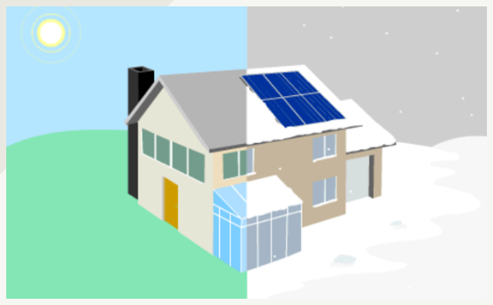**ACTIVITY 2:** *Thermal Energy Transfer*

**GO TO:** <http://pbslm-contrib.s3.amazonaws.com/WGBH/conv16/conv16-int-thermalenergy/index.html#/intro>

**YOUR TASK:** Work through the interactive and answer the questions provided.

**BIG QUESTIONS:**

1. What makes something hot or cold?

|  |
| --- |
|  |
|  |

1. How do things get warmer or cooler?

|  |
| --- |
|  |
|  |

**THE SUN WARMS EARTH:**

1. What keeps our planet at a temperature that can support life?

|  |
| --- |
|  |
|  |

1. Why are some parts of the planet warmer than others?

|  |
| --- |
|  |
|  |

1. How does transfer of thermal energy relate to earthquakes and volcanoes?

|  |
| --- |
|  |
|  |

**AROUND A CAMPFIRE:**

Picture yourself at a campfire. What do you notice?

1. Why might you feel warmer?

|  |
| --- |
|  |

1. What causes the marshmallow to melt?

|  |
| --- |
|  |

1. What should you use to hold the marshmallow over the fire?

|  |
| --- |
|  |

1. Why does smoke rise from the fire?

|  |
| --- |
|  |

**STAYING COOL ON A HOT DAY:**

1. What kinds of floor surfaces feel more comfortable?

|  |
| --- |
|  |

1. How does your body react to the heat?

|  |
| --- |
|  |

1. Where can you go to cool off?

|  |
| --- |
|  |

**SOLAR ENERGY IN YOUR HOME:**

1. How can your house be designed to take advantage of the ways that thermal energy is transferred?

|  |
| --- |
|  |

**ACTIVITY 3:** *Heat vs. Temperature*

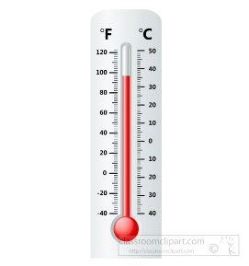**YOUR TASK:** Learn about heat vs. temperature by reading the text below and using the word bank to fill in the missing information.

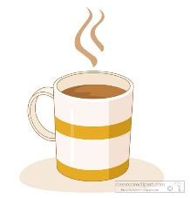Heat and temperature are not the same! Temperature is a measure of how _______ or ________ something is. It is measured in degrees ____________ (oC) .For example: the temperature of ____________ water is 100oC and the temperature that water _____________ at is 0oC.

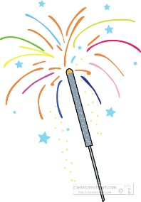 Heat is the amount of ________ energy something has. It is measured in _______ (J). The amount of thermal energy depends on the ________ energy of its particles. The faster the _________ move the more thermal energy it has.

Heat vs Temperature of a sparkler

* The tiny sparks are at a very high _________________ .
* Each particle in the spark is ___________________ a lot because it is very hot.
* But as there are not many _______________, the total amount of heat energy is ______________ .

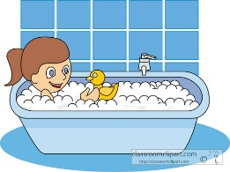Heat vs temperature of a warm bath  
The water is at a _______________ temperature than the sparkler but it contains more heat _______________. This is because it contains more ___________. Each particle is vibrating ____________ as it is at a lower temperature BUT because there are so ______________ - there is more ______________ energy.

Images: <https://classroomclipart.com>

***WORD BANK:***

***celsius*** ***lower*** ***thermal*** ***joules*** ***many*** ***freezes***

***particles*** ***kinetic*** ***less*** ***cold*** ***smaller*** ***boiling***

***energy vibrating temperature hot***